Chongqing Family Translator — Technical Architecture & Design
Oct 7, 2026 · @Khoon Seng

Overview
A voice-first web app turns a Mandarin-speaking tour guide into live Cantonese audio for five family members, and their replies into Mandarin for the guide, over Singapore roaming data in Chongqing.
Only two of the seven adults speak Mandarin. The app removes the need for them to interpret every conversation by hand.
Goals
- Speech is the main input; typing is available as a fallback.
- Every family listener hears Cantonese audio; the guide hears Mandarin audio.
- Large-font text sits beside the audio as a check on meaning.
- Works anywhere in Chongqing on SG roaming or a non-local-breakout eSIM.
- Field-tested and ready in about two months.
Non-goals
- Offline translation, or working on domestic Chinese networks and hotel Wi-Fi.
- Native iOS or Android apps; this is a mobile web app (PWA).
- Simultaneous interpretation. Consecutive interpretation, a few seconds behind the speaker, is the target.
Success criteria
- Translated audio starts within roughly 2–4 seconds of the speaker finishing a sentence.
- The in-laws pick the Cantonese voice and translations in a blind test.
- No bubble is lost after a dead zone or reconnect.
- Daily running cost stays in single-digit US dollars.

Users, languages and channels
The app needs only two audio channels, Cantonese and Mandarin, plus text in three languages.
Person | Speaks | Hears (audio) | Reads (text) | Device
Guide | Mandarin | Mandarin, from the hub speaker | Simplified Chinese on the hub | Shared hub phone
In-laws | Cantonese | Cantonese (must-have, audio first) | Colloquial Cantonese, Traditional characters, large font | Own phone + earphones
Wife's siblings | Cantonese, English | Cantonese (must-have) | Cantonese or English | Own phone + earphones
Khoon Seng and wife | Mandarin, English, Cantonese | None needed | Optional | Operate the hub; human fallback
Input language is chosen explicitly on the hub with Guide and Family talk buttons, because auto-detecting Mandarin versus Cantonese on short clips is unreliable. Family input can be Cantonese or English.
The Cantonese text is written as colloquial spoken Cantonese (粵語口語, e.g. 佢哋喺度等緊我哋), not formal written Chinese, so the same string reads naturally on screen and sounds natural when spoken.

Hub phone and audio capture
The hub is Khoon Seng's own phone with no extra hardware; a clip-on mic is deferred until field tests show it is needed.
Modes
- Guide is a latch: one tap starts continuous listening, and voice-activity detection (Silero VAD) splits the guide's speech at natural pauses, with each chunk capped at 15 seconds. A pause ends a chunk, never the listening session.
- To let family speak, tap Family; tap Guide again to return. The whole screen is tinted a different colour per mode so the current one is unmistakable.
- In Guide mode, segments the STT flags as not Mandarin, or as low confidence, are dropped. This only filters out family chatter; it never chooses the pipeline.
Placement
- In the car: phone in a dashboard or vent mount, bottom edge (main mic) toward the guide, radio off.
- On foot: phone held at chest height, within about 1 m of the guide.
Hub phone rules
- Half-duplex: the hub pauses mic capture while it plays any audio and resumes when playback ends, so it never hears its own Mandarin output as the guide speaking. Browser echo cancellation (echoCancellation: true) stays on as a second layer, not as the main defence.
- No Bluetooth earbuds connected to the hub phone; the phone may silently switch to their mic.
- Bring a car charger and power bank: continuous mic, screen wake lock and roaming data drain the battery fast.
Clip-on mic (deferred)
Decided at the weeks 6–7 field test by comparing transcripts: phone held at 1 m versus a clip-on worn by the person playing the guide. A clip-on only helps on the guide, not on the hub operator. If bought, it is a wireless kit whose receiver plugs into USB-C or Lightning, never Bluetooth, and the app simply uses the phone's default audio input.
Option: the guide holds the hub phone
Instead of Khoon Seng holding the hub near the guide, the guide is handed a spare phone to speak into. The same pattern is being tested with Traverba; decide before weeks 4–5.
- Benefit: the mic sits at the guide's mouth rather than about 1 m away, which should improve STT in noisy places and may remove the need for a clip-on mic.
- Hub behaviour: stays latched in Guide mode; the guide never switches modes. Mandarin replies play from its speaker, since the guide wears no earphones.
- Family replies move to their own phones: the listener screen gains a hold-to-talk Cantonese button, replacing the Family button on the hub.
- The spare phone: needs its own SG roaming or eSIM data (this app is cloud-based), is locked to the app with Guided Access (iOS) or App Pinning (Android), carries no personal accounts, and comes with a lanyard and a power bank.

System architecture
A single Cloud Run service sits between one shared hub phone and five listener phones, calling external STT, translation and TTS APIs on their behalf.
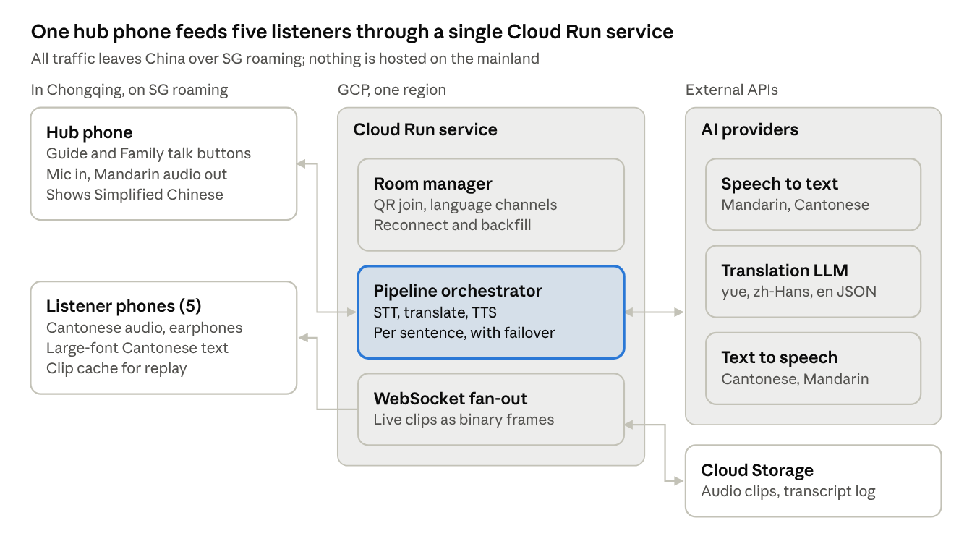
system architecture · hub, Cloud Run, providers, listeners
The hub sends speech in and plays Mandarin out; the orchestrator runs each sentence through the providers, stores the clip in Cloud Storage and pushes it to listeners over WebSockets.
Mermaid version, for the Markdown copy in the repo:
flowchart LR
subgraph CQ["In Chongqing, on SG roaming"]
HUB["Hub phone<br/>Guide / Family modes<br/>Mic in, Mandarin audio out<br/>Simplified Chinese on screen"]
LIS["Listener phones (5)<br/>Cantonese audio, earphones<br/>Large-font Cantonese text<br/>Clip cache for replay"]
end
subgraph GCP["GCP, one region: Cloud Run service"]
ROOM["Room manager<br/>QR join, language channels<br/>Reconnect and backfill"]
ORCH["Pipeline orchestrator<br/>STT, translate, TTS<br/>Per sentence, with failover"]
FAN["WebSocket fan-out<br/>Live clips as binary frames"]
end
subgraph API["External APIs: AI providers"]
STT["Speech to text<br/>Mandarin, Cantonese"]
LLM["Translation LLM<br/>yue, zh-Hans, en JSON"]
TTS["Text to speech<br/>Cantonese, Mandarin"]
end
GCS[("Cloud Storage<br/>Audio clips, transcript log")]
HUB <--> ORCH
ORCH <--> STT
ORCH <--> LLM
ORCH <--> TTS
ORCH --> FAN
ROOM --- FAN
FAN --> LIS
FAN <--> GCS

Translation pipeline
Every sentence runs through one cascade: speech to text, a single translation call, then text-to-speech only for the listeners who need audio.
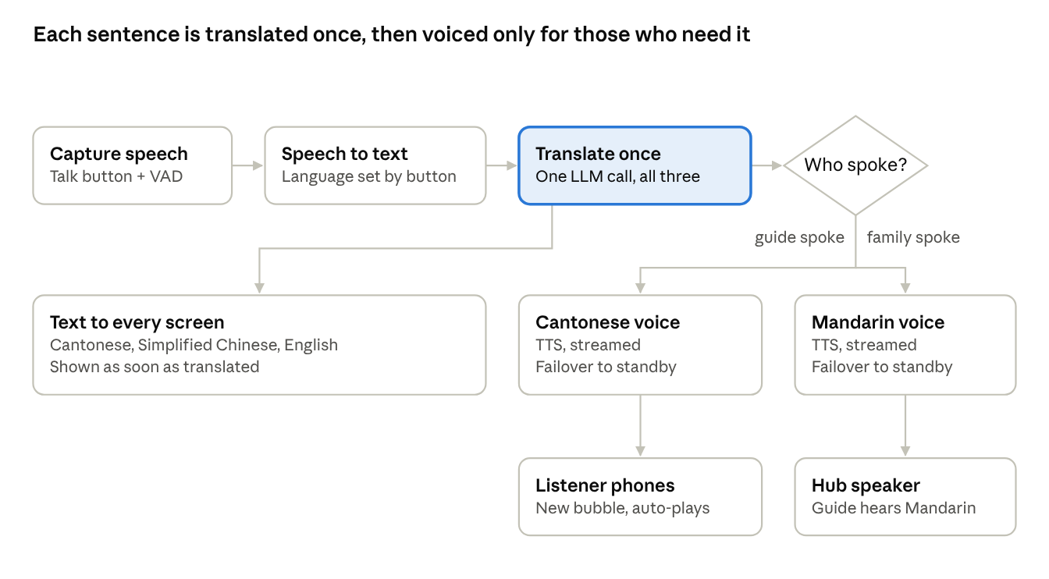
translation pipeline · per sentence
Guide speech becomes Cantonese audio for the listeners; family speech becomes Mandarin audio from the hub speaker. Every screen gets text in all three languages.
Mermaid version, for the Markdown copy in the repo:
flowchart TD
CAP["Capture speech<br/>Guide latch or Family, plus VAD"] --> STT["Speech to text<br/>Language set by mode"]
STT --> TR["Translate once<br/>One LLM call: yue, zh_hans, en"]
TR --> TXT["Text to every screen<br/>Cantonese, Simplified Chinese, English"]
TR --> WHO{"Who spoke?"}
WHO -- guide spoke --> YUE["Cantonese voice<br/>TTS, streamed<br/>Failover to standby"]
WHO -- family spoke --> CMN["Mandarin voice<br/>TTS, streamed<br/>Failover to standby"]
YUE --> LP["Listener phones<br/>New bubble, auto-plays"]
CMN --> HS["Hub speaker<br/>Guide hears Mandarin"]
A single cascade replaces a hybrid of OpenAI's realtime translator plus a Cantonese cascade. One pipeline keeps the Cantonese and Mandarin channels in step and leaves one integration to maintain.

Model and provider choices
Google Cloud is the primary provider for every stage, each stage has a fallback from another provider, and the week-1 bake-off judged by the in-laws confirms or overturns each choice.
Stage | Primary | Fallback | Notes
STT, Mandarin and Cantonese | Google Speech-to-Text V2, chirp_3 model, sync requests only: cmn-Hans-CN (GA), yue-Hant-HK (Preview) | OpenAI gpt-4o-mini-transcribe | Bake-off checks that the fallback doesn't return Mandarin-style text for Cantonese speech
Translation LLM | Decided by 15 Nov using the rule below: Gemini 3.6 Flash on Vertex AI, or Groq | The other of the two. Groq candidates: qwen/qwen3.8-27b (Preview) and openai/gpt-oss-120b (Production) | All candidates pass the same blind test and colloquial-marker check, in both directions
TTS, Cantonese and Mandarin | Google Chirp 3 HD voices (Cantonese yue-HK in Preview) | Google's older non-Chirp voices | In-laws' blind listening test picks the voices
Pause detection | Silero VAD in the browser (@ricky0123/vad-web) | None | 15-second chunk cap; the server splits long transcripts at punctuation
Adapters and credentials. The translation adapter is a single OpenAI-compatible client, configured per provider with a base URL, model and key, so switching between Gemini and Groq is a config change. STT and TTS adapters are provider-specific. On Cloud Run, Google's speech APIs and Gemini on Vertex AI authenticate with the service account, so they need no API keys; only the Groq and OpenAI keys live in Secret Manager. Groq's lineup changes quickly (Qwen3.6-27B was replaced by Qwen3.8-27B within weeks), so model IDs live in config and are re-checked before the trip.
Translation call design. One LLM call per sentence returns all three targets as JSON (yue, zh_hans, en), streamed so TTS can start on the first sentence. The prompt carries a glossary of Chongqing place and dish names (解放碑, 洪崖洞, 磁器口, 毛血旺) and only the last 2–3 utterances as context.
Failover. If a provider errors or is too slow on a sentence, the adapter retries that sentence on the standby. As a last resort the app shows the text and flags the hub operator to interpret.
Ruled out. OpenAI GPT-Realtime-Translate (no Cantonese output voice), conversational realtime models (an assistant, not an interpreter), Groq TTS (no Chinese voices, and Groq does not host Qwen3-TTS), the Gemini API free tier in AI Studio (prompts may be used to improve Google's models, so it fails ZDR), Qwen3-TTS on Alibaba Model Studio (ZDR only for enterprise customers, and flagged content can be kept for up to 2 years) and Azure Speech (kept to one cloud provider). OpenAI's API has no free tier, so it serves only as a paid STT fallback.

Data retention (ZDR) and the primary translation model
Every provider in the stack must keep zero data from the family's conversations; two items depend on Google approving or confirming them, so both requests go in during week 1.
Provider | ZDR status | Action needed
Google Speech-to-Text (sync) | Met by default: audio processed in memory, nothing stored | Never opt into data logging; never use the async (batch) endpoint
OpenAI transcription (STT fallback) | Met by default: no training, no abuse-monitoring or application-state retention on this endpoint | None
Gemini on Vertex AI | Achievable, not automatic | Disable in-memory caching on the project; request Google's abuse-monitoring exception; confirm Gemini 3.6 Flash qualifies
Groq | Self-serve | Switch on Zero Data Retention in Data Controls
Google Text-to-Speech | Not yet confirmed in writing | Ask Google support, or check the Cloud data processing terms
Our own app follows the same rule
- Cloud Storage: a lifecycle rule deletes clips and transcripts after 1 day, which still covers same-day replay and backfill.
- Cloud Run logs hold request IDs, timings and errors only, never transcripts, translations or audio.
- Listener phones clear their IndexedDB cache when someone leaves the room or the day ends.
Choosing the primary translation model
Groq and Gemini on Vertex AI are both configured, each as the other's fallback, because their failures are unrelated: Groq fails by hitting fixed caps, Vertex AI by a busy shared pool returning 429 errors.
- Gemini is primary if Google grants the abuse-monitoring exception and Gemini wins the bake-off.
- Otherwise Groq is primary, using whichever Groq model wins the bake-off. If Qwen3.8-27B and gpt-oss-120b are close, gpt-oss-120b wins because it is a Production model, not Preview.
- Deadline: end of week 5, 15 Nov 2026. Whatever the status is then is what the trip uses, so the field tests run on the final stack.
If Google cannot confirm Text-to-Speech retention, no ZDR-verified Cantonese voice remains among the providers considered. That would need a new search for a ZDR-compliant Cantonese TTS provider, or a decision to accept Google's terms.

Listener experience and playback rules
The listener screen works like a WhatsApp voice-note thread: audio first, large-font Cantonese text under every bubble, and any bubble replayable on its own.
Bubbles
- One bubble per speaker turn; each sentence inside it is its own audio clip.
- Tap a bubble to replay the whole turn; tap a sentence to replay just that sentence.
- The guide's original Mandarin shows in small text under each bubble, so Khoon Seng or his wife can check a confusing translation on the spot.
- Unplayed bubbles carry a visible marker, like unheard voice notes.
Player states
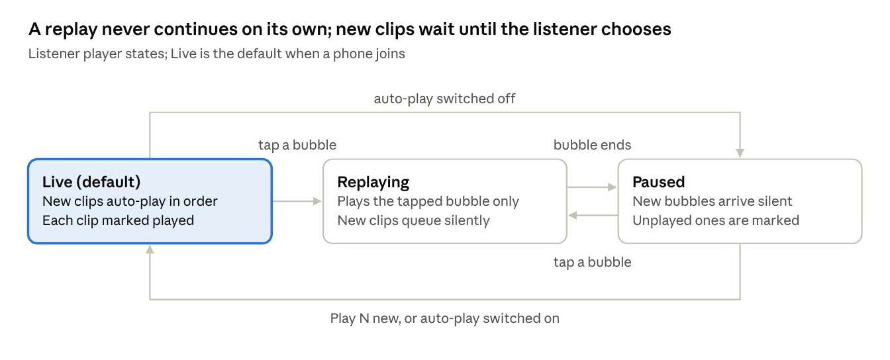
listener player states, Live, Replaying, Paused
A replay plays only the tapped bubble and then stops in Paused; it never runs on into later bubbles. In Paused, new clips arrive silently so the listener can read instead of listen, until they tap Play N new or switch auto-play back on.
Mermaid version, for the Markdown copy in the repo:
stateDiagram-v2
[*] --> Live
Live --> Replaying: tap a bubble
Replaying --> Paused: bubble ends
Paused --> Replaying: tap a bubble
Replaying --> Replaying: tap another bubble (current one stops)
Live --> Paused: auto-play switched off
Paused --> Live: Play N new, or auto-play switched on
note right of Live: New clips auto-play in order, each marked played
note right of Replaying: Plays the tapped bubble only, new clips queue silently
note right of Paused: New bubbles arrive silent, unplayed ones are marked
- Tapping another bubble mid-replay stops the current one at once; two clips never overlap.
- Replays never re-call TTS: clips are cached on the phone (IndexedDB) and backed by Cloud Storage, so a replay works even in a tunnel.
- Each phone shows a tap-to-start screen on joining, which unlocks audio on iOS, and holds a screen Wake Lock while in a room.

Hosting, networking and China access
The roaming SIM, not the cloud region, is what keeps the app reachable in Chongqing; the region is picked by a latency test.
Connectivity
- Every phone uses SG roaming or an eSIM confirmed to route outside China (no local breakout). Traffic exits in Singapore, so Google, OpenAI and Groq behave as they do at home.
- Wi-Fi stays off while the app is in use. Hotel and café Wi-Fi is on the domestic network, where Google domains are blocked whatever the region.
- Nothing is hosted in mainland China, which would need an ICP filing.
Compute: Cloud Run
- One service holds the Vue PWA, the FastAPI WebSocket endpoint and the pipeline, built as one container.
- max-instances=1, because room state lives in memory and a second instance would split the room.
- WebSocket connections are cut at the request timeout (60 minutes maximum); the client's reconnect-and-backfill logic handles it.
- Run at 1 vCPU. Below 1 vCPU, Cloud Run forces maximum concurrency to 1, which would allow only one WebSocket connection.
- Provider API keys live server-side in Secret Manager; phones never call providers directly.
Region
- Candidates: us-central1 (inside the Cloud Storage free tier) and asia-southeast1 (closest to the roaming exit and to Google's Cantonese voices).
- In week 1, deploy to both and measure time-to-first-audio from a Singapore phone. Keep the faster one.
- Cloud Run's free tier is a monthly spending discount per billing account, so it applies in either region.
Storage: Cloud Storage
- Each sentence's audio is saved as an Opus clip, plus a transcript log per room. A lifecycle rule deletes everything after 1 day.
- Live clips travel inline over the WebSocket as binary frames; the bucket serves backfill after reconnects and catch-up fetches.
- A full trip is a few hundred MB, inside the 5 GB free allowance in US regions and pennies elsewhere.
Joining a room. The hub creates a room and shows a QR code holding a short-lived room token. Listeners scan it once, pick their language and stay joined for the day.

Latency, rate limits and cost
The target is about 2–4 seconds from end of sentence to translated audio, at a few US dollars a day; tokens never pile up because every call is stateless.
Latency budget (approximate, to be measured in week 1)
Step | Expected time
STT on one sentence | 0.5–1.5 s
Translation LLM, first sentence streamed | 0.5–1 s
TTS, first audio bytes | 0.5–1 s
Roaming path and region hop | 0.3–0.6 s
Rate limits
- Each STT, translation and TTS request stands alone, so there is no growing context to exhaust. Translation passes only the last 2–3 utterances.
- Groq's free tier caps Whisper at 20 requests per minute and 2,000 per day, and its LLMs at about 1,000 requests per day. Continuous touring exhausts these within hours, so any Groq use needs the paid Developer plan.
- Three design choices keep request counts low: voice-activity detection on the phone so silence is never sent, sentence-sized chunks instead of fixed 2–3 second windows, and one LLM call returning all three languages.
Cost (approximate, for about 3 hours of speech a day)
Item | Free allowance | Estimate for a 7-day trip
STT: Google Chirp 3 | 60 minutes a month, then US$0.016 per minute | About 1,260 minutes, roughly US$19
Translation, if Gemini on Vertex AI is primary | None on Vertex AI | US$1.50 per million input and US$7.50 per million output tokens: roughly US$4–5 a day
Translation, if Groq is primary | Free plan too small for touring; Developer plan | Well under US$1 a day
TTS: Google Chirp 3 HD | 1 million characters a month, then US$30 per million | About 280,000 characters, inside the free allowance
Cloud Run, Cloud Storage, egress | Free tiers | Near zero to a few dollars
Prices were checked against public pricing pages in October 2026 and should be re-checked before the bake-off.

Free tiers, paid plans and billing
Nothing needs a subscription: almost every service is pay-as-you-go with a free allowance, and only Groq has a plan switch. Development runs on free allowances; everything moves to its trip configuration at the start of week 6.
Component | Development (weeks 1–5) | Production (field tests and trip)
Groq | Free plan with ZDR on: 30 requests/min, 1,000/day, 8,000 tokens/min, 200,000 tokens/day (about 220 translations a day) | Developer plan; free caps would run out within the first hour of narration
Gemini | Vertex AI from day one (AI Studio's free tier fails ZDR); cents | Vertex AI pay-as-you-go, about US$4–5 a day as primary
STT (Google Chirp 3) | 60 free minutes a month, then US$0.016/min; a few dollars | About US$19 for the trip
STT fallback (OpenAI) | Small prepaid credit, used only to test failover | Same credit
TTS (Google Chirp 3 HD) | Free (1 million characters a month) | Free (about 280,000 characters)
Cloud Storage | Free in a US region (5 GB-months) | Free in the US; pennies in Singapore
Cloud Run | Free (2 million requests a month, plus compute allowance) | Near free; a dollar or two of WebSocket time
IndexedDB | Built into the browser; free | Same
Secret Manager | Free (6 active secret versions, 10,000 accesses a month) | Same
Artifact Registry | Free up to 0.5 GB; cleanup policy keeps only the last 2 images | Same
Cloud Build and Cloud Logging | Free (120 build-minutes a day; 50 GiB of logs a month) | Same
Network egress to phones | Negligible | About 1 GB for the trip, under a dollar
Silero VAD, Vue, FastAPI | Open source; free | Same
Billing steps
- Day one: enable billing on the Google Cloud project and set a budget alert of about US$20 a month (alerts warn; they don't cap spending). Use Vertex AI for Gemini, and Groq's free plan with ZDR on.
- Start of week 6: upgrade Groq to the Developer plan, top up the OpenAI credit and raise the budget alert to about US$80, so the field tests run on the exact trip configuration.
Expected totals: about US$5–10 for development; for the trip week, about US$55–60 with Gemini as primary or US$25–30 with Groq as primary. A new Google Cloud billing account would also get US$300 of credit.

Alternatives considered
No existing tool delivers private Cantonese audio to each person's own phone, so the app is being built; two free tools stay on as fallbacks.
Tool | What it does well | Why it was not chosen
Google Translate (conversation mode) | Cantonese text and speech; works on SG roaming | One shared device, two people at a time; no private audio per person
Microsoft Translator Converse | Was the closest multi-device group feature | Retired on 30 June 2026
iFlytek app and translator device | Strong Mandarin ↔ Cantonese; works natively in China | Shared device; the app may not appear on the SG App Store; the device costs about ¥5,999
Timekettle earbuds and X1 hub | Cantonese supported; multi-person modes | Group modes need several devices (the X1 needs at least two hubs at €669.40 each); audio is not on each person's own phone
Samsung Interpreter, Apple Live Translation | Both support Cantonese | Built for two people; Apple needs AirPods plus an iPhone 15 Pro or later per listener and may not work in mainland China
WeChat | Cantonese speech-to-text | Text only
Traverba (free version, tested 11 Oct 2026) | Offline, on-device | Failed hands-on testing; see below
Traverba test results
- No group mode in the free version, only a two-person turn-based mode and a live streaming mode.
- Mandarin → Cantonese returned formal written Chinese in Traditional characters, not spoken Cantonese, in both text and audio.
- The turn-based mode stopped listening at the end of the first sentence, so a guide's pauses would cut them off.
- The live mode accepted audio only, no typed input, and played its output on the speaker, then re-captured that output as new input and looped indefinitely.
Lessons carried into this design
- The week-1 bake-off scores Cantonese output for colloquial markers and confirms each voice is a true yue-HK voice.
- Guide mode is a latch: a pause ends a chunk, never the session.
- The hub is half-duplex: it never listens while it is playing audio.
Fallbacks kept for the trip: Google Translate on every family phone for one-to-one exchanges, and a WeChat group with the guide for text logistics.

Risks and mitigations
The biggest risks are audio capture and Cantonese quality, not hosting.
Risk | Impact | Mitigation
eSIM uses local breakout in China | App unreachable | Use SG roaming or a verified eSIM; confirm routing before the trip (there is no ZDR-compliant China-hosted plan B)
Phone joins hotel Wi-Fi | App blocked | Wi-Fi off at start of day; app shows a clear connection banner
Street noise, guide far from the hub | Poor STT | Hold the phone within about 1 m of the guide; add a clip-on mic for the guide only if the field test shows it is needed
Hub mic re-captures its own speaker output | Translation loop, as seen in Traverba | Half-duplex hub (no capture during playback), with browser echo cancellation as a second layer
Family chatter while Guide mode is latched | Junk bubbles transcribed as Mandarin | Listeners on earphones; drop segments flagged as not Mandarin or low confidence
Hub phone battery drains | Translation stops mid-tour | Car charger and power bank
Bluetooth earbuds connected to the hub | Phone silently switches to the earbud mic | Keep the hub phone free of Bluetooth audio devices
Chongqing-accented Mandarin | STT errors | Ask the guide for standard Putonghua; test on Chongqing-accented samples
Translation slips into formal written Chinese or Mandarin grammar | Cantonese sounds wrong to the in-laws | Colloquial-Cantonese prompt; colloquial-marker check and blind bake-off
iOS audio unlock and screen lock | Listener hears nothing | Tap-to-start on join; Wake Lock API; test on the in-laws' actual phones
Tunnels and dead zones | Missed bubbles | Reconnect and backfill from the last utterance id
Cantonese TTS still in Preview at Google | Voice outage | Adapter failover to Google's older voices; last resort text plus human interpreting
Mandarin vs Cantonese auto-detection | Wrong pipeline | Explicit Guide and Family modes on the hub
Listener phones playing aloud | Echo and feedback into the hub mic | Earphones for every listener

Eight-week build plan
Seven weeks of build and field testing start on 12 October, leaving the final week as buffer before an assumed early-December departure.
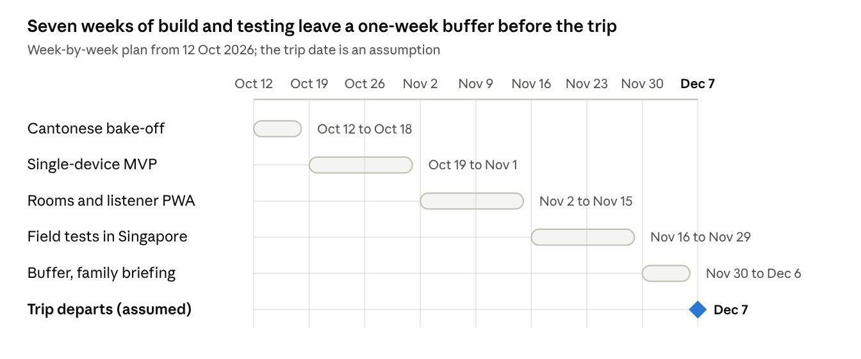
eight-week build plan, by week
Mermaid version, for the Markdown copy in the repo:
gantt
title Eight-week build plan (trip date assumed)
dateFormat YYYY-MM-DD
axisFormat %d %b
section Build
Cantonese bake-off :a1, 2026-10-12, 7d
Single-device MVP :a2, 2026-10-19, 14d
Rooms and listener PWA :a3, 2026-11-02, 14d
section Test
Field tests in Singapore :a4, 2026-11-16, 14d
Buffer and family briefing :a5, 2026-11-30, 7d
section Trip
Trip departs (assumed) :milestone, m1, 2026-12-07, 0d
- Week 1, Cantonese bake-off. Run 10–15 recorded Mandarin narration sentences through 2–3 translation models and 2–3 Cantonese voices, blind, for the in-laws to judge. Score each Cantonese STT on their recorded questions. Check every model's Cantonese for colloquial markers (佢, 係, 嘅, 咩, 唔, 喺, 冇) and confirm each voice is a true yue-HK voice, not a Mandarin voice reading Traditional characters. Deploy a test service to both regions and confirm the eSIM's routing. Enable billing with a budget alert, and send Google both ZDR requests (the Vertex AI abuse-monitoring exception and written confirmation of Text-to-Speech retention).
- Weeks 2–3, single-device MVP. The hub records, shows text and plays audio, with provider adapters in place.
- Weeks 4–5, rooms and listener PWA. QR join, WebSocket fan-out, bubbles, player states, on-phone cache, reconnect and backfill. Lock the primary translation model by 15 Nov.
- Weeks 6–7, field tests in Singapore. Everything first switches to its trip configuration (Groq Developer plan, OpenAI credit topped up, budget alert raised). The family uses their own phones in noisy places such as hawker centres and the MRT, with someone acting as the Mandarin guide. Compare transcripts from the phone held at 1 m against a clip-on worn by the "guide" to decide whether to buy a mic.
- Week 8, buffer. Fixes, then briefing the family on joining a room and using replay.

Open decisions
Eleven decisions remain; most close after the week-1 bake-off. Decided on 7 Oct: the hub is the owner's phone, with Guide mode latching into continuous listening.
- ☐ Trip dates and the final roaming plan or eSIM provider
- ☐ Whether the guide will be driving or seated separately (affects phone placement in the car)
- ☐ Who holds the hub: Khoon Seng, or the guide with a spare phone (see Hub phone and audio capture)
- ☐ Cloud Run region: us-central1 or asia-southeast1, after the latency test
- ☐ Google's answer on the Vertex AI abuse-monitoring exception (request in week 1)
- ☐ Google's written confirmation that Text-to-Speech doesn't retain text (request in week 1)
- ☐ Primary translation model, Gemini on Vertex AI or Groq, by 15 Nov using the decision rule
- ☐ Confirm the STT and TTS primaries (Chirp 3, Chirp 3 HD) or promote a fallback, after the bake-off
- ☐ New-bubble cue while paused: vibration on Android, chime or animation on iOS
- ☐ Clip-on mic for the guide: only if the weeks 6–7 field test shows phone-only is not enough
- ☐ Whether English text shows by default for the wife's siblings

